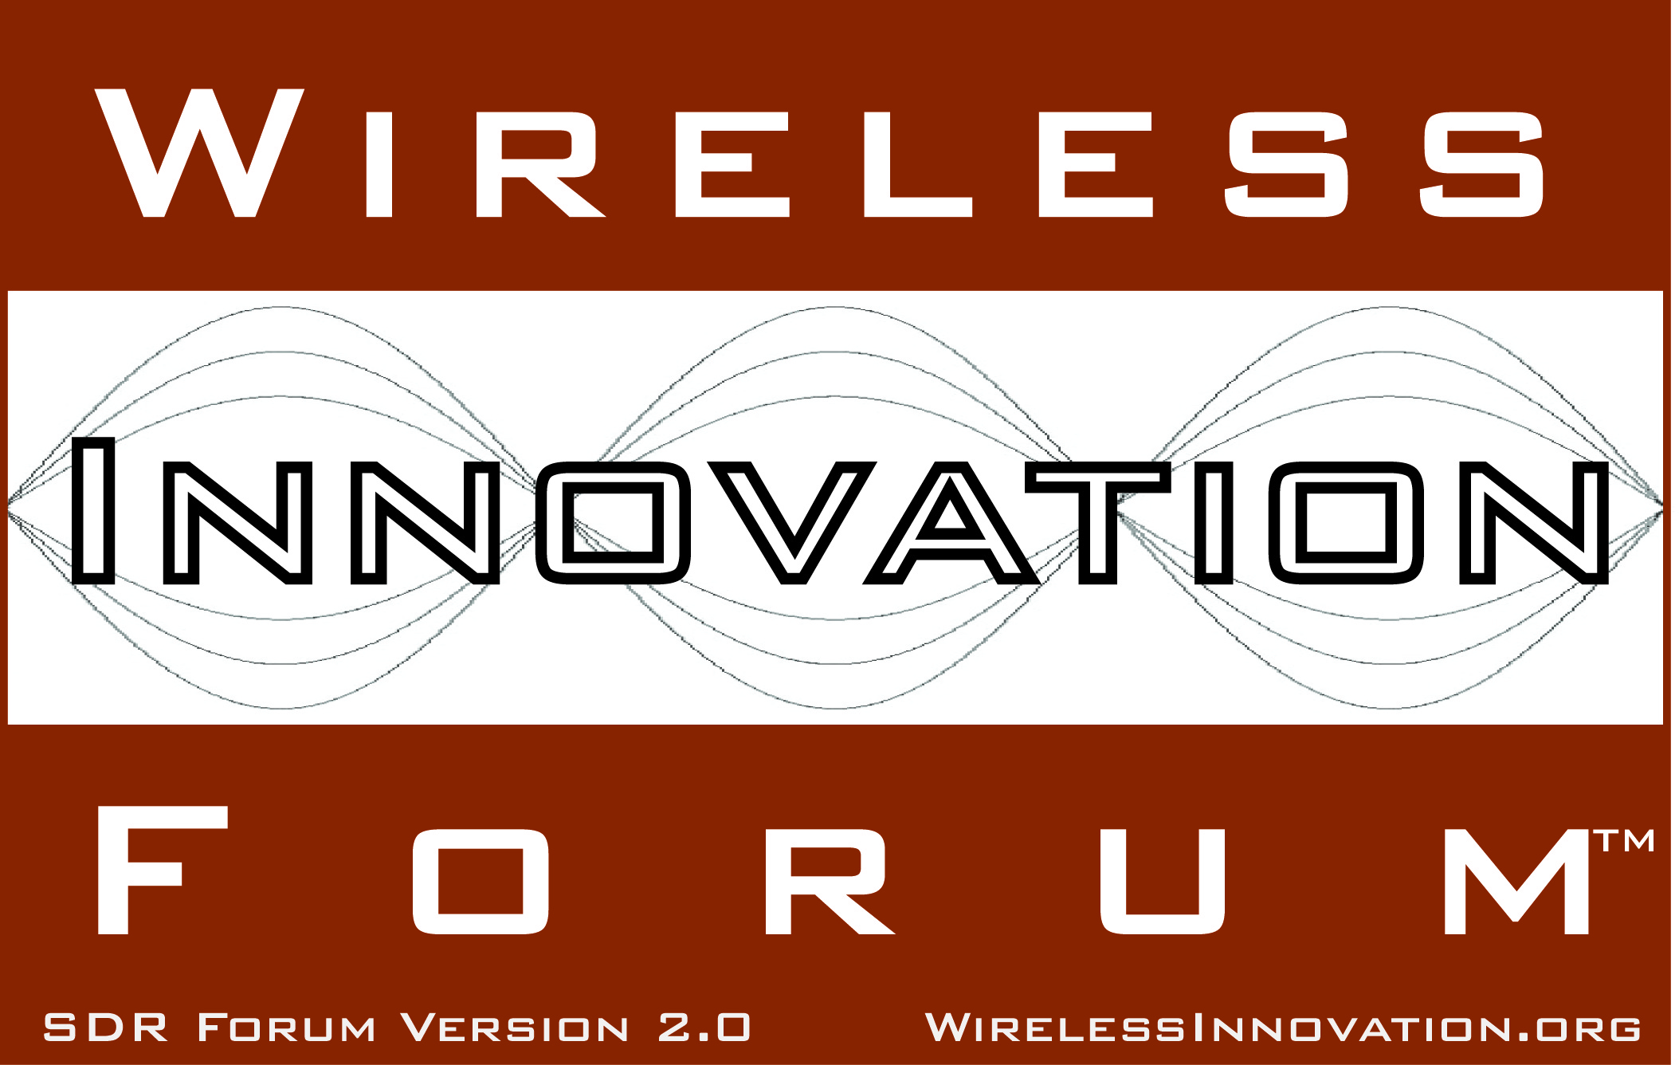

Request for Comment on Amendment to CORBA Profile for SCA Next Adding Lightweight
Working Document WINNF-10-RFI-0004

Version V1.0.0
3 June 2010
TERMS, CONDITIONS & NOTICES

This document has been prepared by the SCA Next Work Group to assist The Software Defined Radio Forum Inc. (or its successors or assigns, hereafter “the Forum”). It may be amended or withdrawn at a later time and it is not binding on any member of the Forum or of the SCA Next Work Group.

Contributors to this document that have submitted copyrighted materials (the Submission) to the Forum for use in this document retain copyright ownership of their original work, while at the same time granting the Forum a non-exclusive, irrevocable, worldwide, perpetual, royalty-free license under the Submitter’s copyrights in the Submission to reproduce, distribute, publish, display, perform, and create derivative works of the Submission based on that original work for the purpose of developing this document under the Forum's own copyright.

Permission is granted to the Forum’s participants to copy any portion of this document for legitimate purposes of the Forum. Copying for monetary gain or for other non-Forum related purposes is prohibited.

THIS DOCUMENT IS BEING OFFERED WITHOUT ANY WARRANTY WHATSOEVER, AND IN PARTICULAR, ANY WARRANTY OF NON-INFRINGEMENT IS EXPRESSLY DISCLAIMED. ANY USE OF THIS SPECIFICATION SHALL BE MADE ENTIRELY AT THE IMPLEMENTER'S OWN RISK, AND NEITHER THE FORUM, NOR ANY OF ITS MEMBERS OR SUBMITTERS, SHALL HAVE ANY LIABILITY WHATSOEVER TO ANY IMPLEMENTER OR THIRD PARTY FOR ANY DAMAGES OF ANY NATURE WHATSOEVER, DIRECTLY OR INDIRECTLY, ARISING FROM THE USE OF THIS DOCUMENT.

Recipients of this document are requested to submit, with their comments, notification of any relevant patent claims or other intellectual property rights of which they may be aware that might be infringed by any implementation of the specification set forth in this document, and to provide supporting documentation.

Wireless Innovation Forum ™ and SDR Forum ™ are trademarks of the Software Defined Radio Forum Inc.

Table of Contents

TERMS, CONDITIONS & NOTICES i
Preface iii
1 Introduction 1
2 Amendments 1
2.1 Amendments to Section 1 1
2.2 Amendment to Section 3 2
2.3 Amendment to Section 4 2
2.4 Additional Section 7 2
2.5 Additional Section 8 2
3 Amended Appendix A 3
4 Data Types in Interfaces 3

Preface
In August 2009, the JPEO and its JTRS SCA Next Working Panel, invited the WINNF to assist it in developing the specification of a new release of the SCA whose working title is “SCA Next.” The WINNF created a “SCA Next Work Group” to coordinate this work and informed the JTRS SCA Next Working Panel that the WINNF wished to take the lead on developing solutions for two of the previously defined Change Proposals: S047 “Develop CORBA/e and CORBA Services wording” and S013 “SCA Architectural Consistency”, as well as offer comments and suggestions for many of the other change proposals.
Discussions with the JTRS working panel clarified that task S047 was primarily to develop a CORBA profile for use in SCA Next replacing the “Minimum CORBA” profile used in SCA 2.2.2. The WINNF work group has worked since that time, using both teleconferences and in-person meetings, and has completed its work on S047.
The WINNF SCA Next Work Group is pleased to contribute the attached proposed amendment to the specification of a CORBA Profile previously proposed to the JTRS SCA Next Working Panel for use as part of SCA Next. The amendment adds an additional profile called “Lightweight” intended for use primarily on DSPs other extremely limited processors. Note that on further consideration, WINNF believes that there is not a sufficient difference between the ‘F’ and ‘C’ profiles and recommends removal of the ‘C’ profile. Note that this relates to Change Proposal S047. The WINNF requests your consideration and invite your comments.
Please respond with your comments to the WINNF at office@wirelessinnovation.org and CC to the SCA Next Work Group Chair: Terry Anderson, terry.anderson@itt.com.

Request for Comment on Amendment to CORBA Profile for SCA Next Adding Lightweight

Introduction
The previously proposed specification for CORBA Profile for SCA Next WINNF-10-RFI-0002 (PROFILE) is to be amended to add an additional profile called “Lightweight” primarily intended for use on DSPs and other extremely limited processors.

Amendments

Amendments to Section 1
Section 1 of PROFILE is to be amended as indicated by change notation below:

Where the SCA Next specifies the use of CORBA by SCA Applications it shall be understood to mean CORBA/e Compact Profile (REF) with the differences specified in this document. This document specifies two profiles based on the CORBA/e Compact profile. The permitted CORBA features are listed in Appendix A. The first profile is intended for Applications that will be hosted on most General Purpose Processor (GPP) platforms and uses the symbol ‘F’ (for Full) in the Appendix A. The second profile is intended for Applications that will be hosted on extremely limited platforms, such as DSPs and uses the symbol ‘L’ (for Lightweight) in Appendix A. It is recommended that if CORBA is not used in DSPs and FPGAs, data types in non-CORBA APIs avoid the types marked as L* in the profile.

Compliance with this specification shall mean that SCA Applications intended for use on general GPP platforms shall only use CORBA features marked with the symbol ‘F’ in the SCA column. SCA Applications intended for use on extremely limited platforms such as many DSPs shall only use CORBA features marked with the symbol “L”. . Features that Applications are not permitted to use have been marked with ‘o’ (for Omit). All platforms (those not severely resource-constrained), shall support all features marked with ‘F’. CORBA ORBs for extremely limited processors shall support, as a minimum, all features marked with “L”.

Platforms may support additional features as desired and may require additional features to fully support SCA Next requirements.

Platform software such as Core Framework and platform Devices and Services are not intended to be restricted by this specification. Such platform software may use additional CORBA features and may require additional features to be fully SCA Next compliant.

Note: paragraphs and sections marked with “[Non-normative]” are for guidance and not part of the specification.

[Non-normative] Because platforms may use additional features, these two “profiles” are not profiles in the same sense as the CORBA/e Compact and Micro profiles. They are not intended to specify complete ORBs for hosting SCA systems.

[Non-normative] With a few noted exceptions, both profiles are proper subsets of the CORBA/e Compact feature list.

Amendment to Section 3
Last paragraph to be amended as follows:

We have also included a column comparing the ‘F’ profile to the CORBA/e Compact profile. This comparison is for convenience and is not normative. The columns use the same ‘R’ and ‘E’ symbols as that for Minimum CORBA.

Amendment to Section 4
Last paragraph to be amended as follows:

With a few noted exceptions, the ‘F’ profile is a proper subset of the CORBA/e Compact profile. This means that a platform with sufficient resources could use a CORBA/e Compact ORB and support nearly all permitted Application features and require minimal porting effort.

Additional Section 7
7 Permitted Data Types
The F profile shall permit all CORBA/e Basic types as defined in CORBA/e 6.10.1 except wchar, shall permit string but not wstring, and shall permit enum. The L profile shall permit the same types as the F profile but it is recommended that only CORBA/e Basic types Boolean, octet, short, unsigned short, long, unsigned long and enum (not allowing char, wchar, string, wstring, float, double, long double, long long, or unsigned long long) be used to enhance compatibility with even more limited processors such as FPGAs. Structs and sequences in all profiles shall contain only the permitted simple types. Profiles F and L shall permit unbounded sequences, but unbounded sequences are discouraged in L. Unions and arrays shall be permitted in F and L but are discouraged in L.

Additional Section 8
8 [Non-normative] Component Model for Profile L
Profile L, the profile for extremely limited platforms, such as most DSPs, assumes a particular model for implementing an SCA component (Resource or Device) that we will call a “Lightweight” component. In order to avoid resource intensive features of the SCA for component management, such as the Resource interface and its inherited PropertySet interface, the model for profile L assumes components that are not full SCA components or that the implementation of a full SCA component is split between the extremely limited platform and some less-limited platform. It is assumed that the component management functions, including the Resource interface are realized on the less-limited platform and that only port implementations (such as traffic data handling) is implemented on the limited processor. An alternative in Applications is for the Assembly Controller to directly manage a Lightweight component, not using a Resource port. So the permitted data types and method calls are restricted to those necessary for these port implementations. Note that some current standard APIs such as, Audio Port Device and GPS Device would need to be modified to follow these restrictions. Coordination between the lightweight and management parts of this component is outside the scope of this recommendation and is not required to use CORBA.
Where lightweight components might need to be deployed on even more limited processors such as FPGAs or where they have interfaces to other components on such processors, compatibility will be enhanced if data types are restricted to those realizable on such processors. So components implementing the lightweight profile are encourage to avoid the data types discouraged in the Permitted Data Types Section and marked with L* in the table 1.

Amended Appendix A
The amended version of Appendix A is attached with L added to appropriate rows. To make the changes easier to see they have been highlighted in light red.

Data Types in Interfaces
The WINNF also recommends a restriction on data types used in any interface to modules implemented on extremely limited platforms such as FPGAs and most DSPs. The recommendation is:
Interfaces to code modules implemented on extremely limited platforms, such as FPGAs and most DSPs, whether or not they are implemented in CORBA, are encouraged not to use the types discouraged in the L CORBA profile and marked with L* in the table.
This recommendation is intended to permit easier porting between CORBA and non-CORBA implementations and to ensure that data can be easily passed among CORBA and non-CORBA components. Since this statement restricts implementation that do not use CORBA, it should be placed somewhere in the SCA specification outside of a CORBA profile section.

